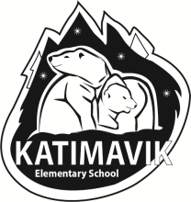
Katimavik School Council

Internet: http://kesparentcouncil.edublogs.org/
Email sc-katimavikes@ocdsb.ca

November 2020

Dear Parents/Guardians,

Katimavik School Council is proud to offer POLAR BEAR SPIRIT WEAR! Show off your school spirit to friends and family in style!

We are offering four styles of clothing for purchase:
- Short-Sleeve T-shirts (100% cotton, black with gold polar bear logo) $18 each;
- Long-sleeve T-shirts (100% cotton, black with gold polar bear logo) $22 each;
- Long-sleeve hoodies (50/50 cotton/poly blend, black hoodie with gold KATIMAVIK on chest or gold hoodie with black KATIMAVIK on chest) $35 each;
- “Pink shirt day” (100% cotton, pink shirt with “don’t be a bully, be a friend” logo) $18 each.

Items are available in both youth and adult sizing from Small (S) to Extra-large (XL).

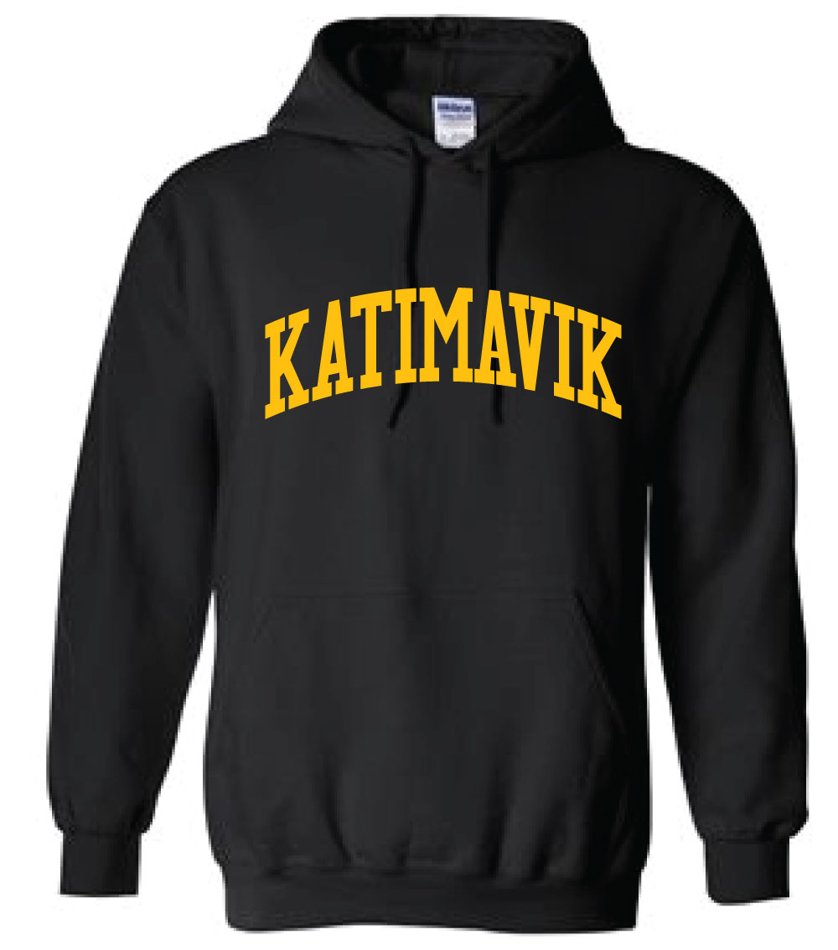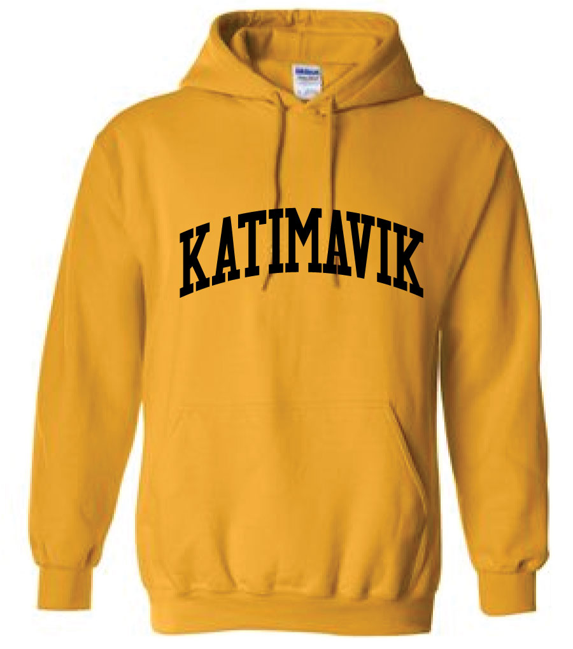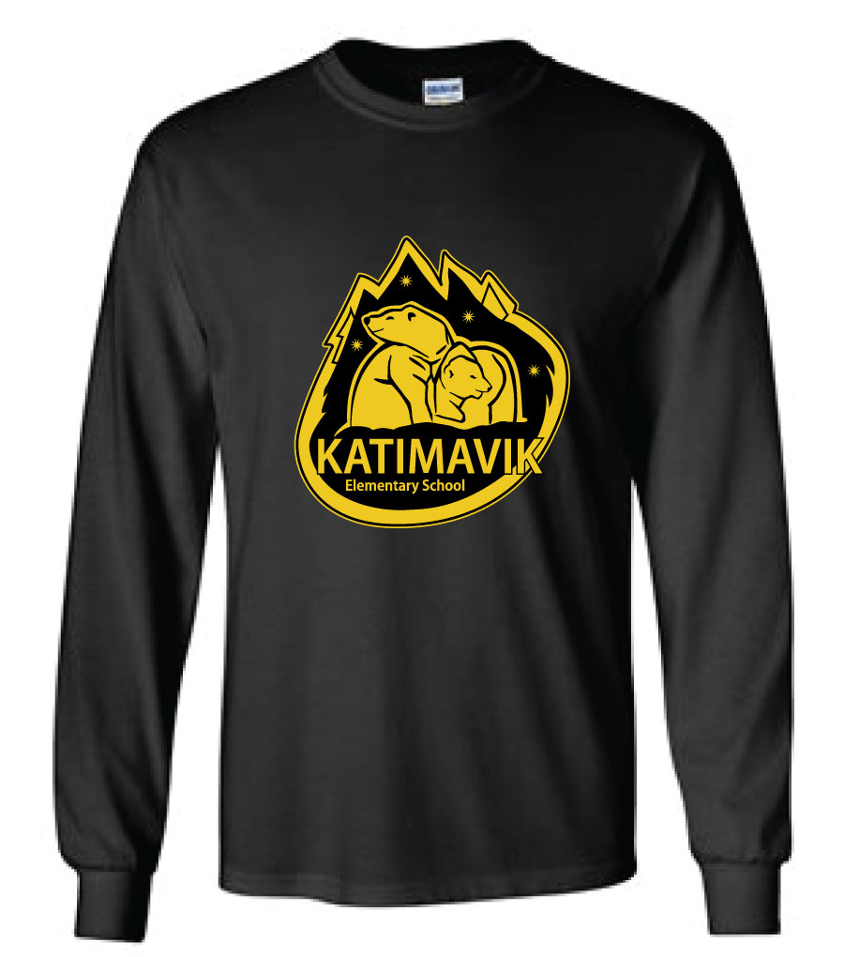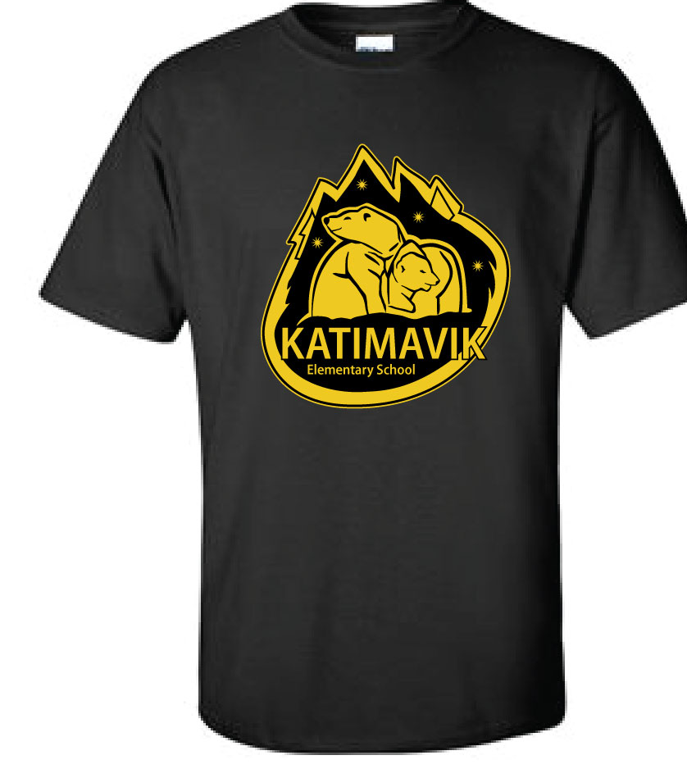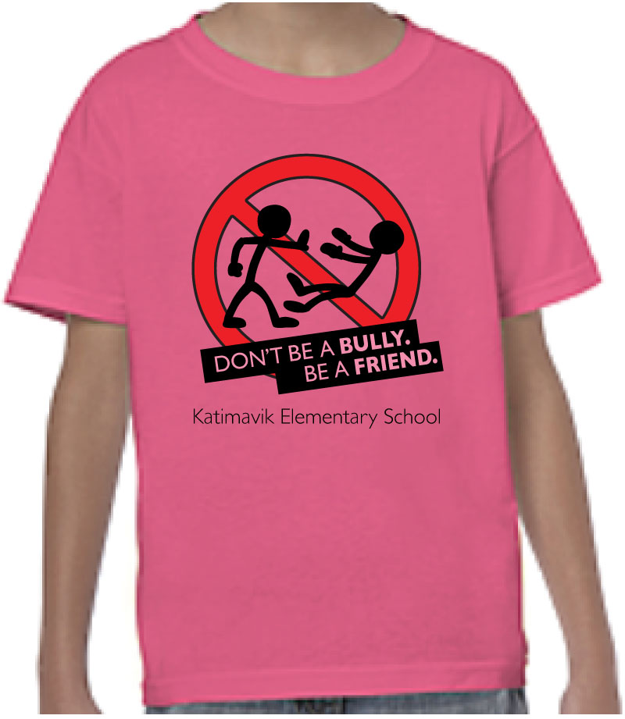

To take advantage of these terrific offers, please…

- Decide which items you wish to purchase and the size needed.
- Log into your school cash online account https://ocdsb.schoolcashonline.com/Home/SignIn

ORDERS ARE DUE Sunday November 22nd
Late orders will NOT be processed and no extra items will be ordered.

***Please note that all items are “made to order”. Refunds or exchanges will only be made if you have been given the wrong item or size by the clothing company, not if the wrong size is ordered.***

Should you have any questions about this project, please contact School Council via email at sc-katimavikes@ocdsb.ca .
sign up for our blog at http://kesparentcouncil.edublogs.org/

Thank you for your support!
Katimavik School Council

